# **CS559 – Computer Vision**

## Assignment No. 1

### Due 9/21/2020[1]*

1. (a) What is an interchange format? (b) Give three examples of interchange formats.

(c) What is the signature of a PGM format. Give two examples of the signature. (d) What is patterning in printing? (e) Explain the principle and operation of error diffusion for printing.

1. (20 points) In an automated manufacturing, inspection of circuit boards is to be done using a CCD camera. The individual imaging elements (photosites) each has a dimension of 5 by 5 m (micron) and the spacing between the elements is 1 m. The circuit boards are 60 by 60 mm, and defects appear as dark circular blobs with diameter of 0.4 mm or larger. The smallest defect must appear in the image as an area of at least 6 by 6 pixels. Assume that available lenses come with focal lengths of multiple of 25 mm, 35 mm and 50 mm, and the available camera resolutions are multiple of 256 by 256 pixels up to 2048 by 2048 pixels (4 Mpix). Manufacturing requirements dictate that distance between camera and the circuit board must be between 200 mm to 500 mm. The image of the board must occupy the whole image plane. You are to select the lens focal length and the minimum camera resolution (number of pixels) required. Show in reasonable details the analysis that lead to your answers. This assignment does not need any programming.
2. What is the storage saving in terms of $b$ and $c$ when reducing a $b$ bit image into $c<b$ bit image?

Write a program to reduce an $b=8$ bit image into a $c<8$ bit image. Do not use the Matlab or Python library, but you can look their function/method to get ideas. Apply your code to the following 8-bit image, with c=4. Show the output image.

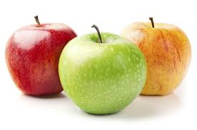

1. The purpose of this program is to understand the representation and manipulation of colors in an image. Consider a color image and suppose we want to keep a particular object in the image in its original color and turn other parts of the image into greyscale. As an example is the image (a) below that should turn into image (b). Write a program to achieve this, and apply your program to two images of your choice to demonstrate the effectiveness of your program.

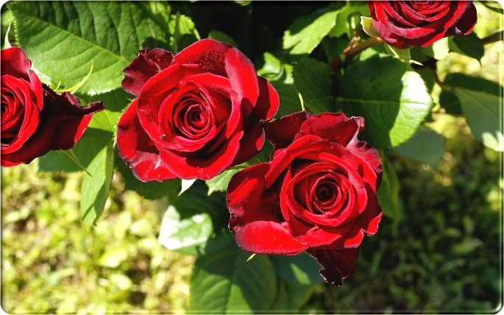 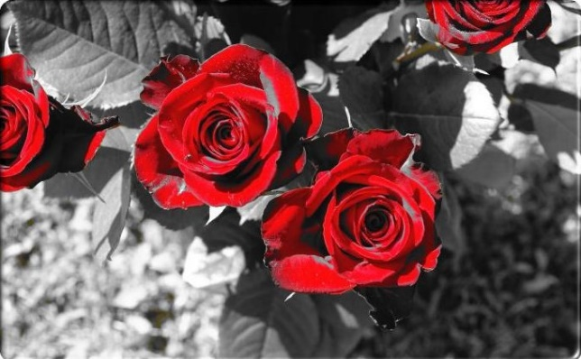

a b

1. * Please type your solutions to Problems 2 using a word processor. Submit as hard copy and a short (150-300 word) report using a word processor. In this report briefly explain the features of your programs, any findings and conclusions. Provide outputs (images) to support your report. Each image must have a detailed caption explaining what processing has been done, etc. Also submit your Mathlab or Python code, and executables. Download this assignment, then open it, click on each image and save it as .jpg, then use the .jpg images. **Include the grading sheet with your name and student number.** 